Implement Azure Web Apps

Lab Objective
In this lab, you will learn how to:
- Create an Azure Web App using App Service
- Deploy application code from GitHub
- Use deployment slots (staging and production)
- Perform a slot swap for safe production deployment
- Configure autoscaling to handle traffic spikes
- Test performance using Azure Load Testing

Business Scenario (Why This Lab Matters)
Your organization:
- Hosts PHP websites on on-premises Windows servers
- Hardware is reaching end-of-life
- Wants to avoid new hardware costs
- Plans to migrate websites to Azure PaaS
➡ Azure Web Apps eliminate server management and provide built-in scaling, security, and high availability.
Architecture diagram
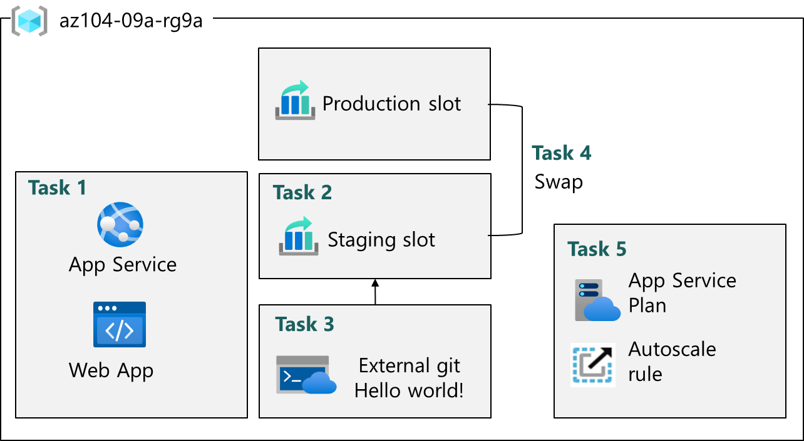

Core Concepts (Understand Before Doing the Lab)

What is Azure App Service?
Azure App Service is a Platform as a Service (PaaS) offering that allows you to:
- Host web applications
- Deploy code without managing servers
- Automatically scale based on demand
Supports:
- PHP
- .NET
- Java
- Python
- Node.js

What is an Azure Web App?
An Azure Web App:
- Is a service running inside Azure App Service
- Hosts your website or API
- Handles OS patching, runtime updates, and availability
You manage:
- Application code
- Configuration
- Scaling rules
Azure manages:
- Servers
- OS
- Platform maintenance

What is an App Service Plan?
An App Service Plan defines:
- CPU
- Memory
- Storage
- Scaling capabilities
- Pricing tier

Important:
Multiple Web Apps can share the same App Service Plan.

Pricing Plan Used in This Lab
Premium V3 (P1V3)
Why:
- Supports deployment slots
- Supports autoscaling
- Better performance
- Zone redundancy support

Task 1: Create and Configure an Azure Web App

What You Did
- Created a Web App with:
  - PHP 8.2 runtime
  - Linux OS
  - Premium V3 plan
  - East US region

Key Configuration Definitions

Publish: Code
Means:
- You deploy application source code
- Not a Docker container

Runtime Stack: PHP 8.2
Defines:
- Programming language and version used by the app

Linux OS
Benefits:
- Lower cost
- Better performance for PHP workloads
- Widely used for modern web hosting

Task 2: Create and Configure a Deployment Slot

What is a Deployment Slot?
A deployment slot is:
- A separate environment for the same web app
- Has its own URL
- Shares the same App Service Plan
Common slots:
- Development
- Staging
- QA
- Production

Why Use Deployment Slots?
Benefit | Explanation
Zero-downtime deployment | No impact to users
Testing | Validate changes before production
Rollback | Quickly revert if issues occur

What You Did
- Created a staging slot
- Did not clone production settings
- Verified different URLs for:
  - Production
  - Staging

Task 3: Configure Web App Deployment Settings

What is Deployment Center?
Deployment Center:
- Configures continuous deployment
- Automatically pulls code from a source repository
Deployment Source Used
External Git Repository
Repository:
https://github.com/Azure-Samples/php-docs-hello-world
Branch:
master

What Happened After Configuration?
- Azure pulled code from GitHub
- Deployed it to the staging slot
- Displayed Hello World page

Continuous Deployment Definition
Continuous Deployment:
- Automatically updates the app when code changes
- Reduces manual deployment effort
- Improves release consistency

Task 4: Swap Deployment Slots

What is Slot Swapping?
Slot swap:
- Exchanges content between slots
- Staging becomes production
- Production becomes staging

Why Slot Swapping Is Important
Benefit | Explanation
No downtime | Swap happens instantly
Safe deployment | Code already tested
Easy rollback | Swap again if needed

What You Verified
- Production URL now displays Hello World
- Application is live for users

Task 5: Configure and Test Autoscaling

What is Autoscaling?
Autoscaling:
- Automatically adjusts resources based on load
- Maintains performance
- Optimizes cost

Scaling Types in App Service
Type | Description
Scale up | Increase CPU/RAM (change plan size)
Scale out | Increase number of instances
✔ This lab focuses on scale out

Automatic Scaling Used
- Enabled Automatic scaling
- Set Maximum burst = 2
Meaning:
- Azure can temporarily add instances during traffic spikes

Load Testing Purpose
Load testing:
- Simulates real user traffic
- Helps validate scaling behavior
- Measures performance metrics

Metrics Observed
Metric | Meaning
Virtual users | Simulated users
Response time | App speed
Requests/sec | Throughput

